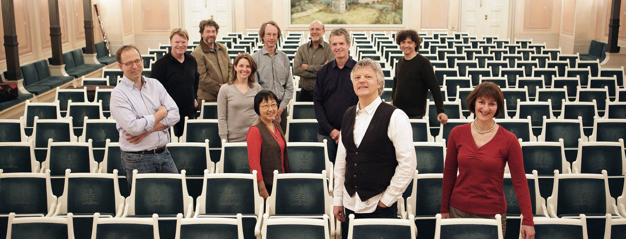

Foto André Mailänder

Successful, fresh, thrilling – all three things for more than fourty years! The Linos Ensemble is constantly accorded such attributes, and this is not just the result of intensive and enthusiastic rehearsals, but has other reasons as well. They include the experience of joint work on interpretation, which is always pions in music. The Neueste Nachrichten in Dresden wrote: ‘It was an exquisite concert the Linos Ensemble gave us. Its name, which derives from Greek mythology, is explained by the title: Linos, the god of rhythm and melody. After what we have heard, we can add: also the god of immense creative power and differentiation of colour’.

The Linos Ensemble was founded by the oboist Klaus Becker in 1977. In its core team of five wind instruments, five strings and piano, it successfully devoted itself to the traditional repertoire of mixed chamber music, before conquering new frontiers: premieres of contemporary compositions, its own concert series in Cologne, journeys of discovery between chamber music and symphony music, special projects on music and language, harmony music to Schubert’s opera Alfonso and Estrella with Hanns Dieter Hüsch or Schoenberg’s Pierrot Lunaire with Salome Kammer.

In the meantime, the ensemble’s repertoire comprises more than 130 works, from Bach to Stockhausen and from the trio to the chamber symphony. The musicians have conquered the CD market with more than 20 excellently reviewed productions, some of which have been awarded prizes such as the recording Louise Farrenc Piano Quintets Nos. 1 and 2, which won the ‘Prize of German Record Criticism’ 3/94 or the Quintet for Piano left-hand of Franz Schmidt, for which the ensemble received the ECHO Klassik 2017. ARD and ZDF have broadcastportrait programmes of the musicians.

Further information:
www.linos-ensemble.de/en

What the critics say
And the members of the Linos Ensemble, whose mandate is to seek out and record chamber works of lesser known composers, like this recent recording of chamber music by Arnold Krug, are so well matched that they generate a much beefier and ample sound, and commited playing, than their crew of eleven would suggest. In these recordings they are joined by baritone Olaf Bär, sopranos Alison Browner and Simone Nold, mezzo-sopranos Marion Eckstein, Zoryana Kushpler and Ivonne Fuchs, tenor Markus Schäfer, and violinist Winfried Rademacher. … An essential compilation for any serious collector offered at a bargain price.
Classical Music Sentinel, Jean-Yves Duperron, 11/ 2018
***
Winfried Rademacher, a student of Josef Suk, plays with tonal sweetness and technical security. He plays the lyric sections in particular with distinction, and marshals that fearsome first movement cadenza with sang froid. The almost religioso element of the opening of the Largo comes over with a particularly intimate refinement in this chamber arrangement, the Linos Ensemble’s thoughtful sonority providing a deft tapestry.
musicweb-international.com, Jonathan Woolf, 4/2016
***
This homage to Arnold Schoenberg’s Association for Private Musical Performances is an undeniable artistic success.
pizzicato, 23.10.2017
***
Best of all is Ukrainian mezzo Zoryana Kushpler, a comprimario at the Vienna Staatsoper who has sung Carmen at the Volksoper. She has a warm, liquid voice, consistently golden over the wide range of these songs, and from pp to ff.
Fanfare, James H. North, © 3/2018
***
A historic recommendation / Een historische aanrader.
www.stretto.be, 19.10.2017
***

Former Suk and Végh student Winfried Rademacher provides an excellent reading in every respect, free from stylistic mannerism and able objectively to convey this vast work effectively, while Capriccio engineers a very high-quality product in association with German broadcaster Deutschlandfunk. The disc is thus unusual and highly successful – a very significant achievement which I enjoyed greatly.
THE STRAD, 11/2016

